 - MAPS OF CLINICS
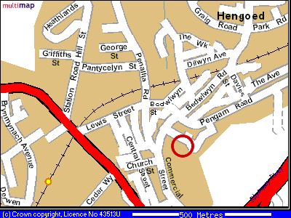 | Hengoed Clinic  Oakfield Street Surgery,  Oakfield Street, Ysrad Mynach, Hengoed, CF82 7AF.  (Rhymney Valley)
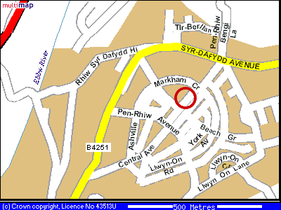 | Oakdale Clinic  Oakdale Medical Centre,  Aberconway Place, Oakdale, Blackwood, NP12 0JX .  (Sirhowy Valley)
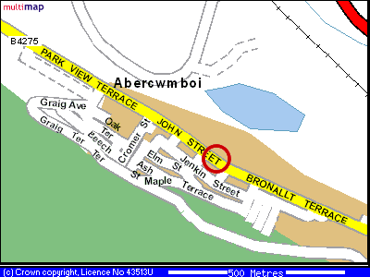 | Aberdare Clinic  John Street, Abercwmboi,  Aberdare, CF44 6BL.  (Cynon Valley)
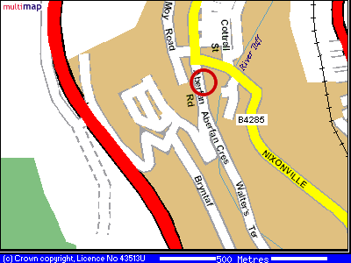 | Aberfan Clinic  Aberfan Rd, Aberfan,  Merthyr Tydfil, CF48 4QN.  (Merthyr Vale)

